FEDERAL INSTITUTE OF SCIENCE AND TECHNOLOGY (FISAT)TM

**HORMIS NAGAR, MOOKKANNOOR**

# ANGAMALY-683577

‘**FOCUS ON EXCELLENCE’ DATA SCIENCE**

………………………………………………

# LABORATORY RECORD

## Name: SANDRA DAVIS

**Branch: MASTER OF COMPUTER APPLICATION**

**Semester: 3 Batch: B Roll No: 38**



# FEDERAL INSTITUTE OF SCIENCE AND TECHNOLOGY (FISAT)TM

**HORMIS NAGAR, MOOKKANNOOR**

# ANGAMALY-683577

‘**FOCUS ON EXCELLENCE’**

## Name : SANDRA DAVIS

**Branch : MASTER OF COMPUTER APPLICATION**

## Semester : 3 Roll No: 38

**University Exam.Reg. No:**

**CERTIFICATE**

*This is to certify that this is a Bonafide record of the Practical work done and submitted to Kerala Technological University in partial fulfillment for the award of the Master Of Computer Applications is a record of the original research work done by* ***SANDRA DAVIS*** *in the* ***DATA SCIENCE*** *Laboratory of the Federal Institute of Science and Technology during the academic year 2021-2022.*

Signature of Staff in Charge Signature of H.O.D

Name: Name:

Date:

## Date of University practical examination ………………………

Signature of Signature of

Internal Examiner External Examiner

|  |  |  |  |  |  |
| --- | --- | --- | --- | --- | --- |
| **CONTENT** | | | | | |
| **SI**  **No** | **Date :** | **Name of Experiment:** | **Page No:** | **Signature of Staff –In – Charge:** |  |
| 1 | 19/11/2021 | Matrix operations (using vectorization) and transformation using python and  SVD using Python | 1 |  |
| 2 | 30/11/2021 | Programs using matplotlib / plotly / bokeh / seaborn for data visualisation. | 4 |  |
| 3 | 26/11/2021 | Programs to handle data using pandas | 15 |  |
| 4 | 07/12/2021 | Program to implement k-NN classification using any standard dataset available in the public domain and find the accuracy of the algorithm. | 22 |  |
| 5 | 14/12/2021 | Program to implement Naïve Bayes Algorithm using any standard dataset available in the public domain and find the accuracy of the algorithm | 28 |  |
| 6 | 04/01/2022 | Program to implement linear and multiple regression techniques using any standard dataset available in the public domain and evaluate its performance. | 31 |  |
| 7 | 14/01/2022 | Program to implement text classification using Support vector machine. | 34 |  |
|  | | | | | |

|  |  |  |  |  |
| --- | --- | --- | --- | --- |
| 8 | 21/12/2022 | Program to implement decision trees using any standard dataset available in the public domain and find the  accuracy of the algorithm | 38 |  |
| 9 | 25/01/2022 | Program to implement k-means clustering technique using any standard dataset available in the  public domain | 40 |  |
| 10 | 28/01/2022 | Programs on feed forward network to classify any standard dataset available in the public domain | 45 |  |
| 11 | 28/01/2022 | Programs on convolutional neural network to classify images from any standard dataset in the public domain. | 47 |  |
|  |  |  |  |  |
|  |  |  |  |  |

DEPARTMENT OF COMPUTER APPLICATION

Page | 1

# AIM

1: Matrix operations(using vectorixation) and transformation using python and SVD

CODE:

a = np.arange(0,4).reshape((2,2)) b = np.eye(2)

print(np.dot(a,b)) ##Matrix multiplication

# OUTPUT:

[[0. 1.]

[2. 3.]]

**CODE:**

x = np.arange(1,10).reshape(3,3) print(x)

# OUTPUT:

[[1 2 3]

[4 5 6]

[7 8 9]]

# CODE:

#SVD image compresion

import matplotlib.pyplot as plt import matplotlib.image as mpimg import numpy as np

img_eg = mpimg.imread("rose.jpg") plt.imshow(img_eg)

print(img_eg.shape) #Operation results: (800, 1280,3)

#Converting image data into two-dimensional matrix and singu- lar value decomposition

img_temp = img_eg.reshape(800, 1280 * 3) U,Sigma,VT = np.linalg.svd(img_temp)

# Take the first 10 singular values sval_nums = 10

DEPARTMENT OF COMPUTER APPLICATION

Page | 2

img_re-

struct1 = (U[:,0:sval_nums]).dot(np.diag(Sigma[0:sval_nums])).dot(VT[0: sval_nums,:])

img_restruct1 = img_restruct1.reshape(800, 1280,3) img_restruct1.tolist()

# Take the first 50 singular values sval_nums = 50

img_re-

struct2 = (U[:,0:sval_nums]).dot(np.diag(Sigma[0:sval_nums])).dot(VT[0: sval_nums,:])

img_restruct2 = img_restruct2.reshape(800, 1280,3)

# Take the first 100 singular values sval_nums = 100

img_re-

struct3 = (U[:,0:sval_nums]).dot(np.diag(Sigma[0:sval_nums])).dot(VT[0: sval_nums,:])

img_restruct3 = img_restruct3.reshape(800, 1280,3)

#Exhibition

fig, ax = plt.subplots(nrows=1, ncols=3) ax[0].imshow(img_restruct1.astype(np.uint8)) ax[0].set(title = "10") ax[1].imshow(img_restruct2.astype(np.uint8)) ax[1].set(title = "50") ax[2].imshow(img_restruct3.astype(np.uint8)) ax[2].set(title = "100")

plt.show()

DEPARTMENT OF COMPUTER APPLICATION

Page | 3

# OUTPUT:

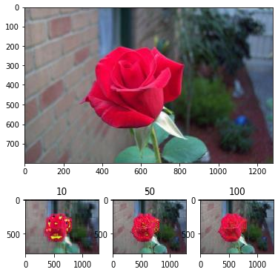

DEPARTMENT OF COMPUTER APPLICATION

Page | 4

AIM

1. Programs using matplotlib / plotly / bokeh / seaborn for data visualisation.

Dataset used: iris.csv

CODE:

import pandas as pd

iris = pd.read_csv(‘iris.csv’)

## Plotting Using Matplotlib import matplotlib.pyplot as plt plt.plot(iris["sepal.length"], "r--") plt.show

OUTPUT:

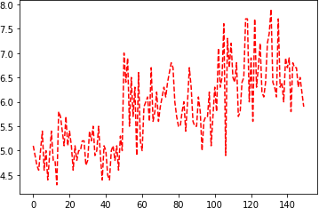

CODE:

## Scatter Plot iris.plot(kind ="scatter",

x ='sepal.length', y ='petal.length')

plt.grid()

DEPARTMENT OF COMPUTER APPLICATION

Page | 5

OUTPUT:

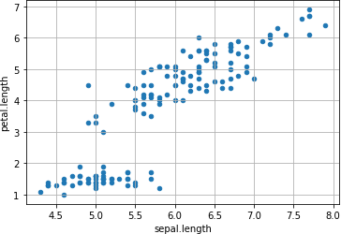

CODE:

## Plotting using Seaborn

import seaborn as sns sns.set_style("whitegrid")

sns.FacetGrid(iris, hue ="variety",height = 6).map(plt.scatter, 'sepal.length', 'petal.length').add_legend()

OUTPUT:

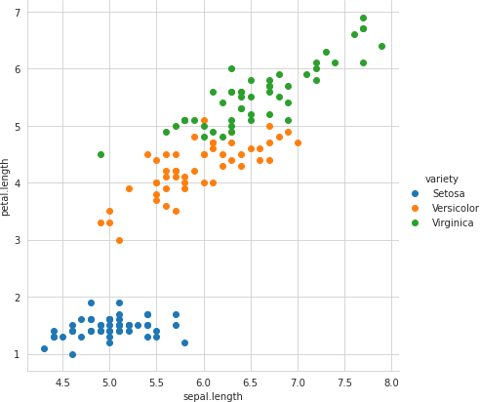

DEPARTMENT OF COMPUTER APPLICATION

Page | 6

CODE:

# Distribution Chart

#Visualizing the target(class label) column

sns.countplot(x='variety', data=iris, ) plt.show()

OUTPUT:

CODE: 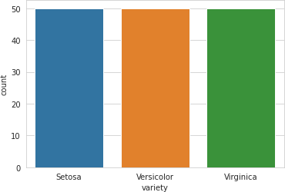

#plotting all the column’s relationships using a pairplot. It can be used for multivariate analysis.

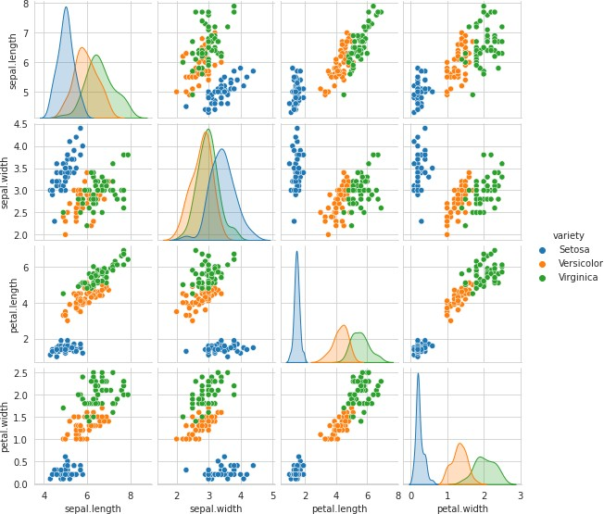sns.pairplot(iris,hue='variety', height=2) OUTPUT:

DEPARTMENT OF COMPUTER APPLICATION

Page | 7

#Histogram for Sepal Length

plt.figure(figsize = (10, 7)) x = iris["sepal.length"]

plt.hist(x, bins = 20, color = "green") plt.title("Sepal Length in cm") plt.xlabel("Sepal_Length_cm") plt.ylabel("Count")

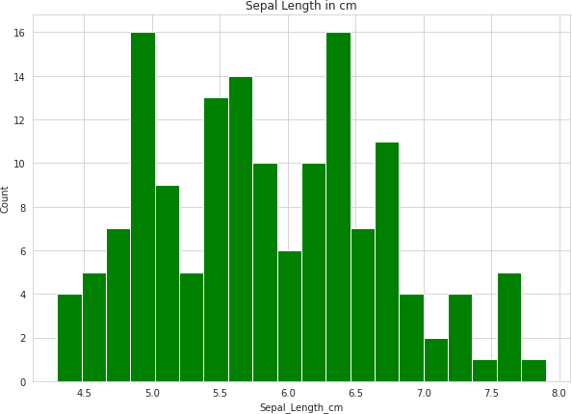OUTPUT:

CODE:

#Histogram for Petal Width plt.figure(figsize = (12, 7)) x = iris["petal.width"]

plt.hist(x, bins =20, color = "blue") plt.title("Petal width in cm") plt.xlabel("Petal_Width_cm") plt.ylabel("Count")

DEPARTMENT OF COMPUTER APPLICATION

Page | 8

OUTPUT:

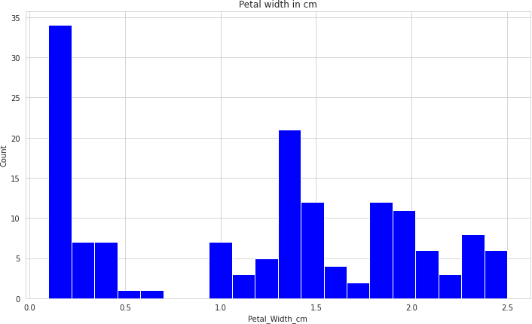

CODE:

#Histograms allow seeing the distribution of data for various columns. # It can be used for uni as well as bi-variate analysis.

fig, axes = plt.subplots(2, 2, figsize=(10,10))

axes[0,0].set_title("Sepal Length") axes[0,0].hist(iris['sepal.length'], bins=7)

axes[0,1].set_title("Sepal Width") axes[0,1].hist(iris['sepal.width'], bins=5);

axes[1,0].set_title("Petal Length") axes[1,0].hist(iris['petal.length'], bins=6);

axes[1,1].set_title("Petal Width") axes[1,1].hist(iris['petal.width'], bins=6);

DEPARTMENT OF COMPUTER APPLICATION

Page | 9

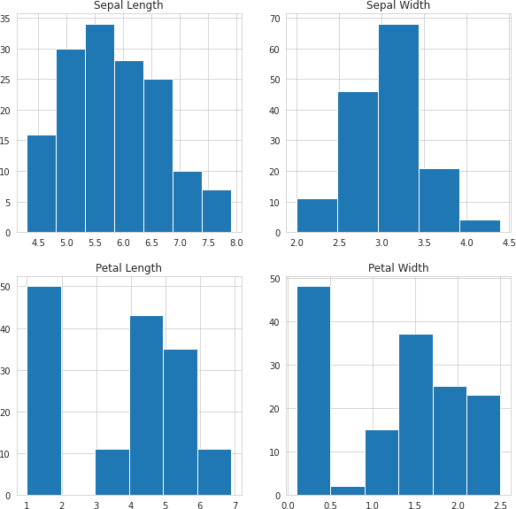OUTPUT:

CODE:

#Histograms with Distplot Plot

plot = sns.FacetGrid(iris, hue="variety") plot.map(sns.distplot, "sepal.length").add_legend()

plot = sns.FacetGrid(iris, hue="variety") plot.map(sns.distplot, "sepal.width").add_legend()

plot = sns.FacetGrid(iris, hue="variety") plot.map(sns.distplot, "petal.length").add_legend()

plot = sns.FacetGrid(iris, hue="variety")

DEPARTMENT OF COMPUTER APPLICATION

Page | 10

plot.map(sns.distplot, "petal.width").add_legend() plt.show()

#In the case of Sepal Length, there is a huge amount of overlapping. #In the case of Sepal Width also, there is a huge amount of overlapping.

#In the case of Petal Length, there is a very little amount of overlapping. #In the case of Petal Width also, there is a very little amount of overlapping.

OUTPUT:

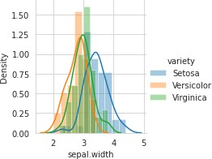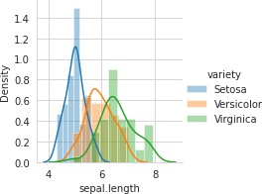

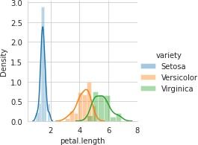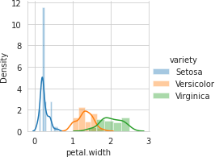

DEPARTMENT OF COMPUTER APPLICATION

Page | 11

CODE:

# Box Plot for Iris Data

plt.figure(figsize = (10, 7)) iris.boxplot()

OUTPUT:

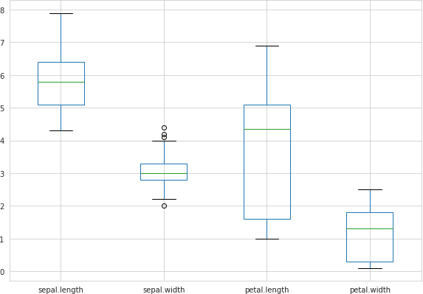

CODE:

import matplotlib.gridspec as gridspec fig = plt.figure(figsize=(9, 40))

outer = gridspec.GridSpec(4, 1, wspace=0.2, hspace=0.2) for i, col in enumerate(iris.columns[:-1]):

inner = gridspec.GridSpecFromSubplotSpec(2, 1,subplot_spec=outer[i], wspace=0.2, hspace=0.4)

ax = plt.Subplot(fig, inner[1])

_ = sns.violinplot(y="variety", x=f"{col}", data=iris, inner='quartile', ax=ax) fig.add_subplot(ax)

fig.show()

OUTPUT:

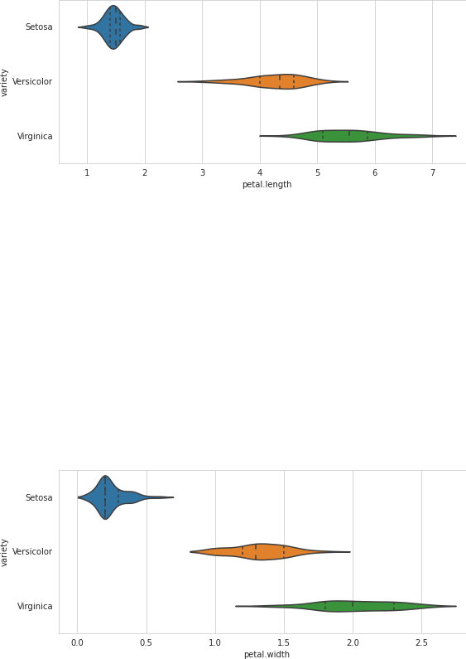

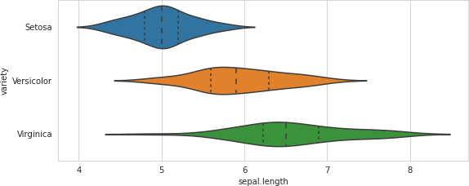

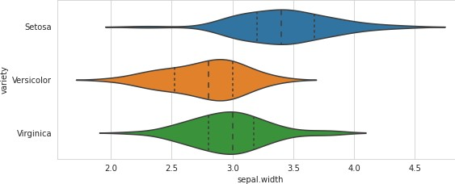

CODE:

# Make default density plot sns.kdeplot(iris['sepal.width'])

OUTPUT:

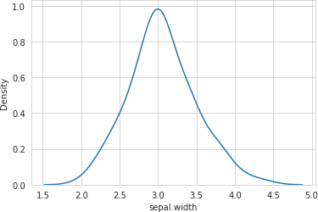

DEPARTMENT OF COMPUTER APPLICATION

Page | 15

AIM

1. Programs to handle data using pandas CODE:

#Pandas is a Python library. #Pandas is used to analyze data. import numpy as np

import pandas as pd

s = pd.Series([1, 3, 5, 6, 8]) print(s)

OUTPUT:

|  |  |
| --- | --- |
| 0 | 1 |
| 1 | 3 |
| 2 | 5 |
| 3 | 6 |
| 4 | 8 |

dtype: int64

CODE:

dict = {"country": ["Brazil", "Russia", "India", "China", "South Africa"],

"capital": ["Brasilia", "Moscow", "New Dehli", "Beijing", "Pretoria"],

"area": [8.516, 17.10, 3.286, 9.597, 1.221],

"population": [200.4, 143.5, 1252, 1357, 52.98] }

b = pd.DataFrame(dict) print(b)

OUTPUT

country capital area population

|  |  |  |  |  |
| --- | --- | --- | --- | --- |
| 0 | Brazil | Brasilia | 8.516 | 200.40 |
| 1 | Russia | Moscow | 17.100 | 143.50 |
| 2 | India | New Dehli | 3.286 | 1252.00 |
| 3 | China | Beijing | 9.597 | 1357.00 |
| 4 | South Africa | Pretoria | 1.221 | 52.98 |

CODE:

b.index = ["BR", "RU", "IN", "CH", "SA"]

DEPARTMENT OF COMPUTER APPLICATION

Page | 16

print(b) OUTPUT:

|  |  |  |  |  |
| --- | --- | --- | --- | --- |
|  | country | capital | area | population |
| BR | Brazil | Brasilia | 8.516 | 200.40 |
| RU | Russia | Moscow | 17.100 | 143.50 |
| IN | India | New Dehli | 3.286 | 1252.00 |
| CH | China | Beijing | 9.597 | 1357.00 |
| SA | South Africa | Pretoria | 1.221 | 52.98 |

CODE:

import pandas as pd

cars = pd.read_csv('cars1.csv') print(cars)

OUTPUT:

Car Model Volume Weight CO2

1. Toyoty Aygo 1000 790 99
2. Mitsubishi Space Star 1200 1160 95
3. Skoda Citigo 1000 929 95 3 Fiat 500 900 865 90 4 Mini Cooper 1500 1140 105 5 VW Up! 1000 929 105 6 Skoda Fabia 1400 1109 90

7 Mercedes A-Class 1500 1365 92 8 Ford Fiesta 1500 1112 98 9 Audi A1 1600 1150 99 10 Hyundai I20 1100 980 99

1. Suzuki Swift 1300 990 101
2. Ford Fiesta 1000 1112 99
3. Honda Civic 1600 1252 94 14 Hundai I30 1600 1326 97 15 Opel Astra 1600 1330 97 16 BMW 1 1600 1365 99

17 Mazda 3 2200 1280 104

18 Skoda Rapid 1600 1119 104

19 Ford Focus 2000 1328 105

1. Ford Mondeo 1600 1584 94
2. Opel Insignia 2000 1428 99
3. Mercedes C-Class 2100 1365 99
4. Skoda Octavia 1600 1415 99 24 Volvo S60 2000 1415 99

25 Mercedes CLA 1500 1465 102 26 Audi A4 2000 1490 104

27 Audi A6 2000 1725 114

28 Volvo V70 1600 1523 109

29 BMW 5 2000 1705 114

30 Mercedes E-Class 2100 1605 115 31 Volvo XC70 2000 1746 117 32 Ford B-Max 1600 1235 104 33 BMW 216 1600 1390 108

DEPARTMENT OF COMPUTER APPLICATION

Page | 17

CODE:

import pandas as pd

cars = pd.read_csv('cars1.csv') cars = pd.read_csv('/cars1.csv') print(cars)

# Print out first 4 observations print(cars[0:4])

# Print out fifth and sixth observation print(cars[4:6])

import pandas as pd

cars = pd.read_csv('cars1.csv', index_col = 0) #first column is taen as index column

print(cars.iloc[2])

|  |  |
| --- | --- |
| OUTPUT: |  |
| Model | Citigo |
| Volume | 1000 |
| Weight | 929 |
| CO2 | 95 |

Name: Skoda, dtype: object

CODE:

#Slicing dataframe import pandas as pd

df = pd.DataFrame([['Jay','M',18],['Jennifer','F',17],

['Preity','F',19],['Neil','M',17]],

columns = ['Name','Gender','Age'])

print(df)

df1 = df.iloc[2:,:]

df2 = df.iloc[:2,:] print(df1) print(df2)

OUTPUT

Name Gender Age

1. Jay M 18
2. Jennifer F 17
3. Preity F 19
4. Neil M 17

DEPARTMENT OF COMPUTER APPLICATION

Page | 18

Name Gender Age

1. Preity F 19
2. Neil M 17

Name Gender Age

1. Jay M 18
2. Jennifer F 17

CODE:

import pandas as pd import numpy as np

#Create a series with 4 random numbers s = pd.Series(np.random.randn(4)) print(s)

print ("The actual data series is:") print( s.values)

OUTPUT:

0 -1.138968

1 -1.097746

2 0.109717

3 1.159537

dtype: float64

The actual data series is:

[-1.13896826 -1.09774589 0.10971687 1.15953676]

CodeText

CODE:

print (s.head(2)) OUTPUT:

0 -1.138968

1 -1.097746

dtype: float64

CODE:

print(s.tail(3))

DEPARTMENT OF COMPUTER APPLICATION

Page | 19

OUTPUT:

1 -1.097746

2 0.109717

3 1.159537

dtype: float64

CODE:

d = {'Name':pd.Series(['Tom','James','Ricky','Vin','Steve','Smith','Jack']), 'Age':pd.Series([25,26,25,23,30,29,23]), 'Rating':pd.Series([4.23,3.24,3.98,2.56,3.20,4.6,3.8])}

# Create a DataFrame df = pd.DataFrame(d) print(df)

print ("The transpose of the data series is:") print(df.T)

OUTPUT:

Name Age Rating 0 Tom 25 4.23

1 James 26 3.24

2 Ricky 25 3.98

3 Vin 23 2.56

4 Steve 30 3.20

5 Smith 29 4.60

6 Jack 23 3.80

The transpose of the data series is:

|  |  |  |  |  |  |  |  |
| --- | --- | --- | --- | --- | --- | --- | --- |
|  | 0 | 1 | 2 | 3 | 4 | 5 | 6 |
| Name | Tom | James | Ricky | Vin | Steve | Smith | Jack |
| Age | 25 | 26 | 25 | 23 | 30 | 29 | 23 |
| Rating  CODE: | 4.23 | 3.24 | 3.98 | 2.56 | 3.2 | 4.6 | 3.8 |

import pandas as pd import numpy as np

#Create a Dictionary of series

d = {'Name':pd.Series(['Tom','James','Ricky','Vin','Steve','Smith','Jack']), 'Age':pd.Series([25,26,25,23,30,29,23]), 'Rating':pd.Series([4.23,3.24,3.98,2.56,3.20,4.6,3.8])}

#Create a DataFrame df = pd.DataFrame(d) print(df)

print ("Row axis labels and column axis labels are:") print (df.axes)

DEPARTMENT OF COMPUTER APPLICATION

Page | 20

OUTPUT:

Name Age Rating

|  |  |  |
| --- | --- | --- |
| 0 | Tom 25 | 4.23 |
| 1 | James 26 | 3.24 |
| 2 | Ricky 25 | 3.98 |
| 3 | Vin 23 | 2.56 |
| 4 | Steve 30 | 3.20 |
| 5 | Smith 29 | 4.60 |
| 6 | Jack 23 | 3.80 |

Row axis labels and column axis labels are: [RangeIndex(start=0, stop=7, step=1), Index(['Name', 'Age', 'Rating'], dtype='object')]

CODE:

import pandas as pd import numpy as np

#Create a Dictionary of series

d = {'Name':pd.Series(['Tom','James','Ricky','Vin','Steve','Smith','Jack']), 'Age':pd.Series([25,26,25,23,30,29,23]),

'Rating':pd.Series([4.23,3.24,3.98,2.56,3.20,4.6,3.8])

}

#Create a DataFrame df = pd.DataFrame(d) print ("Our object is:") print (df)

print ("The dimension of the object is:") print (df.ndim)

OUTPUT:

Name Age Rating

|  |  |  |
| --- | --- | --- |
| 0 | Tom 25 | 4.23 |
| 1 | James 26 | 3.24 |
| 2 | Ricky 25 | 3.98 |
| 3 | Vin 23 | 2.56 |
| 4 | Steve 30 | 3.20 |
| 5 | Smith 29 | 4.60 |
| 6 | Jack 30 | 3.80 |

Our object is:

The shape of the object is: (7, 3)

CODE:

print (df.size) OUTPUT: 21

DEPARTMENT OF COMPUTER APPLICATION

Page | 21

CODE:

print (df.values) OUTPUT:

[['Tom' 25 4.23]

['James' 26 3.24]

['Ricky' 25 3.98]

['Vin' 23 2.56]

['Steve' 30 3.2]

['Smith' 29 4.6]

['Jack' 30 3.8]]

CODE:

df.isnull().sum() #sum returns the number of missing values OUTPUT:

Name 0

Age 0

Rating 0

dtype: int64

CODE:

df = pd.DataFrame(np.arange(12).reshape(3, 4), columns=['A', 'B', 'C', 'D']) print(df)

OUTPUT:

A B C D 0 0 1 2 3

1 4 5 6 7

2 8 9 10 11

DEPARTMENT OF COMPUTER APPLICATION

Page | 22

# AIM

4: Program to implement k-NN classification using any standard dataset available in the public domain and find the accuracy of the algorithm.

# CODE:

from sklearn.neighbors import KNeighborsClassifier from sklearn.model_selection import train_test_split from sklearn.metrics import classification_report import pandas as pd

df = pd.read_csv("iris.csv") print(df)

OUTPUT:

sepal.length sepal.width petal.length petal.width variety

|  |  |  |  |  |  |
| --- | --- | --- | --- | --- | --- |
| 0 | 5.1 | 3.5 | 1.4 | 0.2 | Setosa |
| 1 | 4.9 | 3.0 | 1.4 | 0.2 | Setosa |
| 2 | 4.7 | 3.2 | 1.3 | 0.2 | Setosa |
| 3 | 4.6 | 3.1 | 1.5 | 0.2 | Setosa |
| 4 | 5.0 | 3.6 | 1.4 | 0.2 | Setosa |
| .. | ... | ... | ... | ... | ... |
| 145 | 6.7 | 3.0 | 5.2 | 2.3 | Virginica |
| 146 | 6.3 | 2.5 | 5.0 | 1.9 | Virginica |
| 147 | 6.5 | 3.0 | 5.2 | 2.0 | Virginica |
| 148 | 6.2 | 3.4 | 5.4 | 2.3 | Virginica |
| 149  [150 rows x 5 | 5.9  columns] | 3.0 | 5.1 | 1.8 | Virginica |

# CODE:

df['variety'].value_counts()

|  |  |
| --- | --- |
| OUTPUT: |  |
| Setosa | 50 |
| Versicolor | 50 |
| Virginica | 50 |

Name: variety, dtype: int64

CODE:

X = df.drop('variety', axis=1) y = df['variety']

# splitting to trainset and Test set in the ratio 70:30

X_train, X_test, y_train, y_test = train_test_split(X, y, test_size=0.30)

print(X_train) print(" ")

DEPARTMENT OF COMPUTER APPLICATION

Page | 23

print(X_test) OUTPUT:

sepal.length sepal.width petal.length petal.width

|  |  |  |  |  |  |  |
| --- | --- | --- | --- | --- | --- | --- |
| 46 |  | 5.1 | | 3.8 | 1.6 | 0.2 |
| 95 |  | 5.7 | | 3.0 | 4.2 | 1.2 |
| 67 |  | 5.8 | | 2.7 | 4.1 | 1.0 |
| 45 |  | 4.8 | | 3.0 | 1.4 | 0.3 |
| 143  ..  116 |  | 6.8  ...  6.5 | | 3.2  ...  3.0 | 5.9  ...  5.5 | 2.3  ...  1.8 |
| 41 |  | 4.5 | | 2.3 | 1.3 | 0.3 |
| 62 |  | 6.0 | | 2.2 | 4.0 | 1.0 |
| 91 |  | 6.1 | | 3.0 | 4.6 | 1.4 |
| 123 |  | 6.3 | | 2.7 | 4.9 | 1.8 |
| [105 | rows x 4 | columns] | |  |  |  |
|  | sepal.length | | sepal.width | | petal.length | petal.width |
| 25 | 5.0 | | 3.0 | | 1.6 | 0.2 |
| 141 | 6.9 | | 3.1 | | 5.1 | 2.3 |
| 125 | 7.2 | | 3.2 | | 6.0 | 1.8 |
| 102 | 7.1 | | 3.0 | | 5.9 | 2.1 |
| 128 | 6.4 | | 2.8 | | 5.6 | 2.1 |
| 122 | 7.7 | | 2.8 | | 6.7 | 2.0 |
| 76 | 6.8 | | 2.8 | | 4.8 | 1.4 |
| 103 | 6.3 | | 2.9 | | 5.6 | 1.8 |
| 14 | 5.8 | | 4.0 | | 1.2 | 0.2 |
| 37 | 4.9 | | 3.6 | | 1.4 | 0.1 |
| 100 | 6.3 | | 3.3 | | 6.0 | 2.5 |
| 63 | 6.1 | | 2.9 | | 4.7 | 1.4 |
| 64 | 5.6 | | 2.9 | | 3.6 | 1.3 |
| 61 | 5.9 | | 3.0 | | 4.2 | 1.5 |
| 17 | 5.1 | | 3.5 | | 1.4 | 0.3 |
| 74 | 6.4 | | 2.9 | | 4.3 | 1.3 |
| 111 | 6.4 | | 2.7 | | 5.3 | 1.9 |
| 120 | 6.9 | | 3.2 | | 5.7 | 2.3 |
| 79 | 5.7 | | 2.6 | | 3.5 | 1.0 |
| 85 | 6.0 | | 3.4 | | 4.5 | 1.6 |
| 49 | 5.0 | | 3.3 | | 1.4 | 0.2 |
| 21 | 5.1 | | 3.7 | | 1.5 | 0.4 |
| 110 | 6.5 | | 3.2 | | 5.1 | 2.0 |
| 149 | 5.9 | | 3.0 | | 5.1 | 1.8 |
| 72 | 6.3 | | 2.5 | | 4.9 | 1.5 |
| 11 | 4.8 | | 3.4 | | 1.6 | 0.2 |
| 36 | 5.5 | | 3.5 | | 1.3 | 0.2 |
| 6 | 4.6 | | 3.4 | | 1.4 | 0.3 |
| 68 | 6.2 | | 2.2 | | 4.5 | 1.5 |
| 144 | 6.7 | | 3.3 | | 5.7 | 2.5 |
| 43 | 5.0 | | 3.5 | | 1.6 | 0.6 |
| 80 | 5.5 | | 2.4 | | 3.8 | 1.1 |
| 32 | 5.2 | | 4.1 | | 1.5 | 0.1 |
| 7 | 5.0 | | 3.4 | | 1.5 | 0.2 |
| 55 | 5.7 | | 2.8 | | 4.5 | 1.3 |
| 129 | 7.2 | | 3.0 | | 5.8 | 1.6 |
| 117 | 7.7 | | 3.8 | | 6.7 | 2.2 |

DEPARTMENT OF COMPUTER APPLICATION

Page | 24

12 4.8 3.0 1.4 0.1

# CODE:

print("Number transactions X_train dataset: ", X_train.shape) print("Number transactions y_train dataset: ", y_train.shape) print("Number transactions X_test dataset: ", X_test.shape) print("Number transactions y_test dataset: ", y_test.shape)

# OUTPUT:

Number transactions X_train dataset: (105, 4) Number transactions y_train dataset: (105,) Number transactions X_test dataset: (45, 4) Number transactions y_test dataset: (45,)

# CODE:

classifier = KNeighborsClassifier(n_neighbors=5) classifier.fit(X_train, y_train)

y_pred = classifier.predict(X_test) print(y_pred)

print(' ') print(y_test)

OUTPUT:

['Setosa' 'Virginica''Virginica''Virginica''Virginica''Virginica' 'Versicolor''Virginica''Setosa''Setosa''Virginica' 'Versicolor' 'Versicolor''Versicolor''Setosa''Versicolor''Virginica''Virginica

'Versicolor''Versicolor''Setosa''Setosa' 'Virginica''Virginica' 'Virginica''Setosa''Setosa''Setosa''Versicolor''Virginica''Setosa

'Setosa' 'Virginica' 'Versicolor' 'Setosa' 'Setosa' 'Virginica' 'Versicolor''Virginica''Versicolor''Virginica''Setosa''Virginica'

'Virginica' 'Setosa']

1. Versicolor
2. Versicolor

61 Versicolor

17 Setosa

74 Versicolor

111 Virginica

120 Virginica

79 Versicolor

85 Versicolor

49 Setosa

21 Setosa

110 Virginica

149 Virginica

72 Versicolor

11 Setosa

36 Setosa

6 Setosa

68 Versicolor

DEPARTMENT OF COMPUTER APPLICATION

Page | 25

144 Virginica

43 Setosa

47 Setosa

77 Versicolor

80 Versicolor

32 Setosa

7 Setosa

148 Virginica

88 Versicolor

137 Virginica

55 Versicolor

112 Virginica

29 Setosa

129 Virginica

117 Virginica

12 Setosa

Name: variety, dtype: object

# CODE:

from sklearn.metrics import confusion_matrix print(confusion_matrix(y_test, y_pred)) print(classification_report(y_test, y_pred))

OUTPUT:

[[15 0 0]

|  |  |  |  |  |
| --- | --- | --- | --- | --- |
| [ 0 11 2] |  | | | |
| [ 0 0 17]] | precision | recall | f1-score | support |
| Setosa | 1.00 | 1.00 | 1.00 | 15 |
| Versicolor | 1.00 | 0.85 | 0.92 | 13 |
| Virginica | 0.89 | 1.00 | 0.94 | 17 |
| accuracy |  |  | 0.96 | 45 |
| macro avg | 0.96 | 0.95 | 0.95 | 45 |
| weighted avg | 0.96 | 0.96 | 0.95 | 45 |
| **CODE:** |  |  |  |  |

weather=['Sunny','Sunny','Overcast','Rainy','Rainy','Rainy',

'Over cast','Sunny','Sunny', 'Rainy','Sunny','Overcast','Over- cast','Rainy']

# Second Feature temp=['Hot','Hot','Hot','Mild','Cool','Cool','Cool','Mild', 'Cool'

,'Mild','Mild','Mild','Hot','Mild'] # Label or target varible

play=['No','No','Yes','Yes','Yes','No','Yes','No','Yes','Yes', 'Ye s','Yes','Yes','No']

DEPARTMENT OF COMPUTER APPLICATION

Page | 26

from sklearn import preprocessing #creating labelEncoder

le = preprocessing.LabelEncoder()

# Converting string labels into numbers. weather_encoded=le.fit_transform(weather) print(weather_encoded)

**OUTPUT:**

[2 2 0 1 1 1 0 2 2 1 2 0 0 1]

# CODE:

temp_encoded=le.fit_transform(temp) print(temp_en- coded)

print(" ") la- bel=le.fit_transform(play) print(label)

DEPARTMENT OF COMPUTER APPLICATION

Page | 27

**OUTPUT:**

[1 1 1 2 0 0 0 2 0 2 2 2 1 2]

[0 0 1 1 1 0 1 0 1 1 1 1 1 0]

# CODE:

features=list(zip(weather_encoded,temp_encoded)) print(features)

**OUTPUT:**

[(2, 1), (2, 1), (0, 1), (1, 2), (1, 0), (1, 0), (0, 0), (2, 2),

(2, 0), (1, 2), (2, 2), (0, 2), (0, 1), (1, 2)]

# CODE:

from sklearn.neighbors import KNeighborsClassifier model = KNeighborsClassifier(n_neighbors=3)

from sklearn.neighbors import KNeighborsClassifier model = KNeighborsClassifier(n_neighbors=3)

# Train the model using the training sets model.fit(features,label)

predicted= model.predict([[0,1]]) # 0:Overcast, 1:Hot print(predicted)

**OUTPUT:**

[1]

DEPARTMENT OF COMPUTER APPLICATION

Page | 28

# AIM

5: Program to implement Naïve Bayes Algorithm using any standard dataset available in the public domain and find the accuracy of the algorithm.

# CODE:

## Dataset used: Social_Network_Ads.csv

import pandas as pd

dataset = pd.read_csv("/content/Social_Network_Ads.csv") print(dataset.describe())

print(dataset.head())

X = dataset.iloc[:, [1, 2, 3]].values y = dataset.iloc[:, -1].values

from sklearn.preprocessing import LabelEncoder le = LabelEncoder()

X[:,0] = le.fit_transform(X[:,0])

from sklearn.model_selection import train_test_split X_train, X_test, y_train, y_test = train_test_split(X, y, test_si ze = 0.20, random_state = 0)

**OUTPUT:**

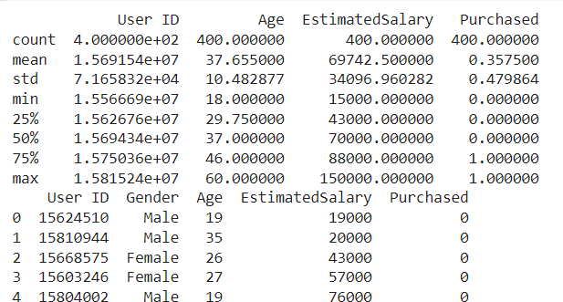

DEPARTMENT OF COMPUTER APPLICATION

Page | 29

# CODE:

from sklearn.preprocessing import StandardScaler sc = StandardScaler()

X_train = sc.fit_transform(X_train) X_test = sc.transform(X_test)

from sklearn.naive_bayes import GaussianNB classifier = GaussianNB() classi- fier.fit(X_train, y_train)

# OUTPUT:

GaussianNB()

# CODE:

y_pred = classifier.predict(X_test)

y_pred

# OUTPUT:

array([0, 0, 1,

|  |  |  |  |  |  |  |  |  |  |  |  |  |  |  |  |  |  |  |
| --- | --- | --- | --- | --- | --- | --- | --- | --- | --- | --- | --- | --- | --- | --- | --- | --- | --- | --- |
| 0, | 0, | 0, | 0, | 0, | 0, | 1, | 0, | 0, | 0, | 0, | 0, | 0, | 0, | 1, | 0, | 0, | 1, | 0, |
| 1, | 0, | 1, | 0, | 0, | 0, | 0, | 0, | 0, | 1, | 0, | 0, | 0, | 0, | 0, | 0, | 1, | 0, | 0, |
| , 0, | 0, | 1, | 0, | 1, | 1, | 0, | 0, | 1, | 1, | 0, | 0, | 0, | 1, | 0, | 0, | 1, | 0, | 0, |

0, 0,

0, 1,

0,

1

0, 0, 0, 0, 1, 0, 0, 0, 0, 0, 0, 0, 1, 1])

# CODE:

y_pred = classifier.predict(X_test)

y_test

DEPARTMENT OF COMPUTER APPLICATION

Page | 30

**OUTPUT:**

array([0, 0, 1,

|  |  |  |  |  |  |  |  |  |  |  |  |  |  |  |  |  |  |  |
| --- | --- | --- | --- | --- | --- | --- | --- | --- | --- | --- | --- | --- | --- | --- | --- | --- | --- | --- |
| 0, | 0, | 0, | 0, | 0, | 0, | 1, | 0, | 0, | 0, | 0, | 0, | 0, | 0, | 0, | 0, | 0, | 1, | 0, |
| 1, | 0, | 1, | 0, | 0, | 0, | 0, | 0, | 1, | 1, | 0, | 0, | 0, | 0, | 0, | 0, | 1, | 0, | 0, |
| , 0, | 0, | 1, | 0, | 1, | 1, | 0, | 0, | 0, | 1, | 1, | 0, | 0, | 1, | 0, | 0, | 1, | 0, | 1, |

0, 0,

0, 1,

0,

1

0, 0, 0, 0, 1, 0, 0, 1, 0, 0, 0, 0, 1, 1])

# CODE:

from sklearn.metrics import confusion_matrix,accuracy_score cm = confusion_matrix(y_test, y_pred)

ac = accuracy_score(y_test,y_pred) print(cm)

print(ac)

**OUTPUT:**

[[56 2]

[ 4 18]]

0.925

DEPARTMENT OF COMPUTER APPLICATION

Page | 31

# AIM

6: Program to implement linear and multiple regression techniques using any standard dataset available in the public domain and evaluate its

performance.

# CODE:

import matplotlib.pyplot as plt

x = [5,7,8,7,2,17,2,9,4,11,12,9,6]

y = [99,86,87,88,111,86,103,87,94,78,77,85,86]

plt.scatter(x, y) plt.show()

**OUTPUT:**

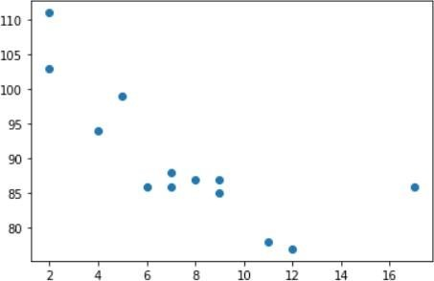

# CODE:

import matplotlib.pyplot as plt from scipy import stats

x = [5,7,8,7,2,17,2,9,4,11,12,9,6]

y = [99,86,87,88,111,86,103,87,94,78,77,85,86]

+slope, intercept, r, p, std_err = stats.linregress(x, y) # r corre lation coefficiant # p probability of hypothesis

def myfunc(x):

DEPARTMENT OF COMPUTER APPLICATION

Page | 32

return slope * x + intercept mymodel = list(map(myfunc, x))

plt.scatter(x, y) plt.plot(x, mymodel) plt.show()

# OUTPUT:

-0.758591524376155

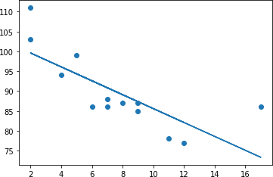

# CODE:

import pandas import warnings

warnings.filterwarnings("ignore") df = pandas.read_csv("cars1.csv")

X = df[['Weight', 'Volume']] y = df['CO2']

DEPARTMENT OF COMPUTER APPLICATION

Page | 33

from sklearn import linear_model

regr = linear_model.LinearRegression() regr.fit(X, y)

# OUTPUT:

LinearRegression()

# CODE:

predictedCO2 = regr.predict([[2300, 1000]]) print(predictedCO2)

# OUTPUT:

[104.86715554]

DEPARTMENT OF COMPUTER APPLICATION

Page | 34

# AIM

* 1. Program to implement text classification using Support vector machine.

# CODE:

## Dataset used: iris.csv

import numpy as np

import matplotlib.pyplot as plt from sklearn import svm, datasets

# import some data to play with iris = datasets.load_iris()

X = iris.data[:, :2] # we only take the first two features.

We could

# avoid this ugly slicing by using a two-dim dataset y = iris.target

# we create an instance of SVM and fit out data. We do not scale our

# data since we want to plot the support vectors C = 1.0 # SVM regularization parameter

svc = svm.SVC(kernel='linear', C=1,gamma='auto').fit(X, y) # create a mesh to plot in

#x_min, x_max = X[:, 0].min() - 1, X[:, 0].max() + 1

#y_min, y_))max = X[:, 1].min() - 1, X[:, 1].max() + 1 #h = (x_max / x_min)/100

#xx, yy = np.meshgrid(np.arange(x_min, x_max, h), #np.arange(y_min, y_max, h

plt.subplot(1, 1, 1)

Z = svc.predict(np.c_ravel[xx.(), yy.ravel()]) Z = Z.reshape(xx.shape)

plt.contourf(xx, yy, Z, cmap=plt.cm.Paired, alpha=0.8)

plt.scatter(X[:, 0], X[:, 1], c=y, cmap=plt.cm.Paired) plt.xlabel('Sepal length')

plt.ylabel('Sepal width') plt.xlim(xx.min(), xx.max())

DEPARTMENT OF COMPUTER APPLICATION

Page | 35

plt.title('SVC with linear kernel') plt.show()

# OUTPUT:

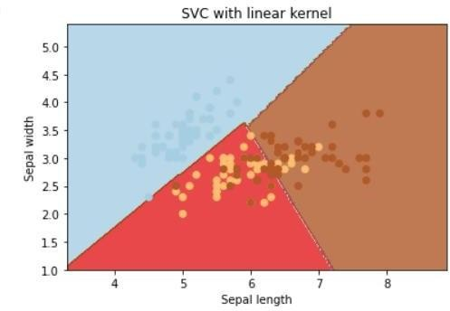

**CODE:**

## Dataset used: True.csv, Fake.csv

#Importing Libraries import pandas as pd import numpy as np

from sklearn.model_selection import train_test_split from sklearn.pipeline import Pipeline

from sklearn.feature_extraction.text import CountVectorizer from sklearn.feature_extraction.text import TfidfTransformer

from sklearn.metrics import accuracy_score, confusion_matrix,class ification_report

from sklearn.svm import LinearSVC import csv

true = pd.read_csv("True.csv") fake = pd.read_csv("Fake.csv")

DEPARTMENT OF COMPUTER APPLICATION

Page | 36

fake['target'] = 'fake' true['target'] = 'true' #News dataset

news = pd.concat([fake, true]).reset_index(drop = True) news.head()

news.dropna()

# OUTPUT:

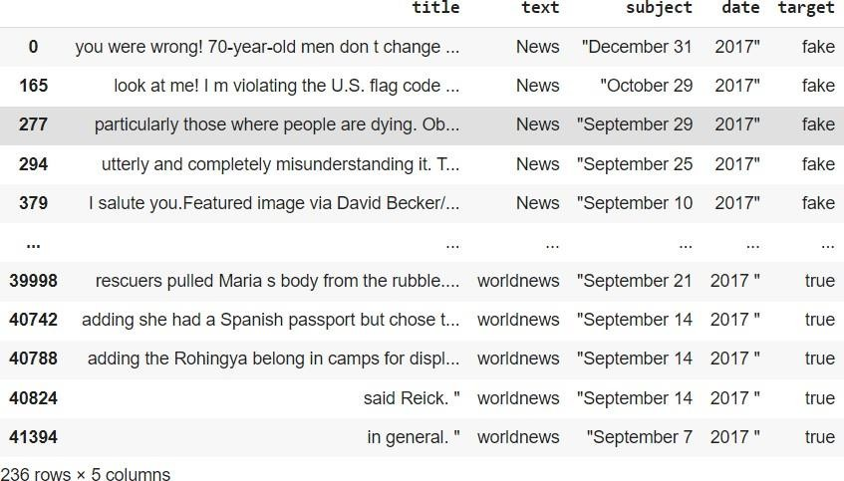

**CODE:**

#Train-test split

x_train,x_test,y_train,y_test = train_test_split(news['text'], new s.target, test_size=0.2, random_state=1)

#Term frequency(TF)=count(word)/total(words)6+ 0ZXCVBNM,./ #TF-

IDF: we can even reduce the weightage of more common words like (t he, is, an etc.) which occurs in all document.

#This is called as TF-

IDF i.e Term Frequency times inverse document frequency.

#count vectorizer : involves counting the number of occurrences ea ch word appears in a document

pipe2 = Pipeline([('vect', CountVectorizer()), ('tfidf', TfidfTran sformer()), ('model', LinearSVC())])

model_svc = pipe2.fit(x_train.astype('U'), y_train.astype('U')) svc_pred = model_svc.predict(x_test.astype('U'))

print("Accuracy of SVM Classifier: {}%".format(round(accuracy_scor e(y_test, svc_pred)*100,2)))

print("\nConfusion Matrix of SVM Classifier:\n") print(confusion_matrix(y_test, svc_pred)) print("\nClassification Report of SVM Classifier:\n") print(classification_report(y_test, svc_pred))

# OUTPUT:

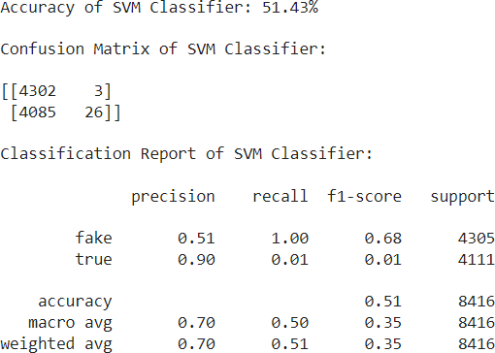

**AIM**

* 1. Program to implement decision trees using any standard dataset available in the public domain and find the accuracy of the algorithm.

# CODE:

## Dataset used: iris

import numpy as np import pandas as pd

import matplotlib.pyplot as plt

from sklearn.datasets import load_iris

data=load_iris() X=data.data y=data.target print(X.shape,y.shape)

# OUTPUT:

(150, 4) (150,)

# CODE:

from sklearn.model_selection import train_test_split

from sklearn.tree import DecisionTreeClassifier#for checking testi ng results

from sklearn.metrics import classification_report, confusion_matri x#for visualizing tree

from sklearn.tree import plot_tree

X_train, X_test, y_train, y_test = train_test_split(X , y, test_si ze = 25, random_state = 10)

clf=DecisionTreeClassifier() clf.fit(X_train,y_train)

# OUTPUT:

DecisionTreeClassifier()

# CODE:

y_pred =clf.predict(X_test)

print("Classification report - \n", classification_report(y_test,y

_pred))

# OUTPUT:

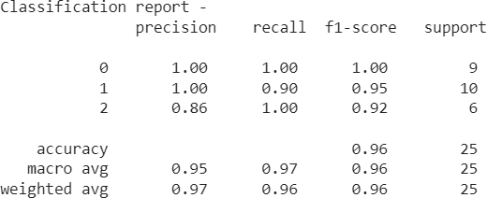

**CODE:**

cm = confusion_matrix(y_test, y_pred) print(cm)

from sklearn import tree

fig,axes = plt.subplots(nrows=1,ncols=1,figsize =(3,3),dpi=200) tree.plot_tree(clf,feature_names=data.feature_names,class_names=da ta.target_names,filled=True)

plt.show() fig.savefig("/con- tent/iris_tree.png")

# OUTPUT:

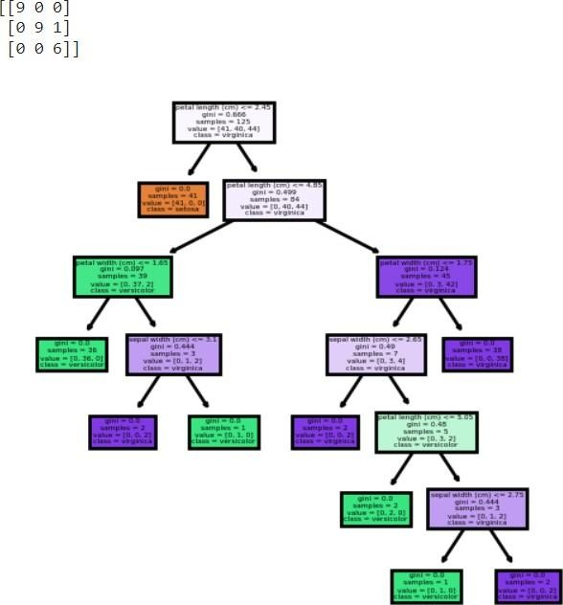

DEPARTMENT OF COMPUTER APPLICATION

Page | 40

# AIM

* 1. Program to implement k-means clustering technique using any standard dataset available in the public domain.

# CODE:

## Dataset used: GENERAL.csv

# importing the libraries import numpy as np import pandas as pd

%matplotlib inline

import matplotlib.pyplot as plt da- taset= pd.read_csv('./CC GENERAL.csv')

|  |  |  |
| --- | --- | --- |
| # checking the presence of null  print(dataset.isnull().sum()) | values |  |
| #CREDIT_LIMIT |  | 1 |
| #MINIMUM_PAYMENTS |  | 313 |

# OUTPUT:

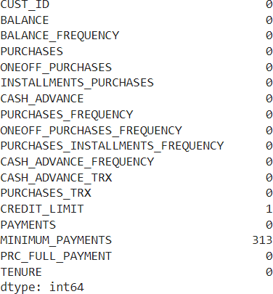

DEPARTMENT OF COMPUTER APPLICATION

Page | 41

# CODE:

dataset['CREDIT_LIMIT'].fillna(dataset.CREDIT_LIMIT.mean(), inplac e = True) dataset['MINIMUM_PAYMENTS'].fillna(dataset.MINIMUM_PAY- MENTS.mean()

, inplace = True) # unfilled vaues replaced using mean print(dataset.isnull().sum()) print(dataset.de- scribe())

# OUTPUT:

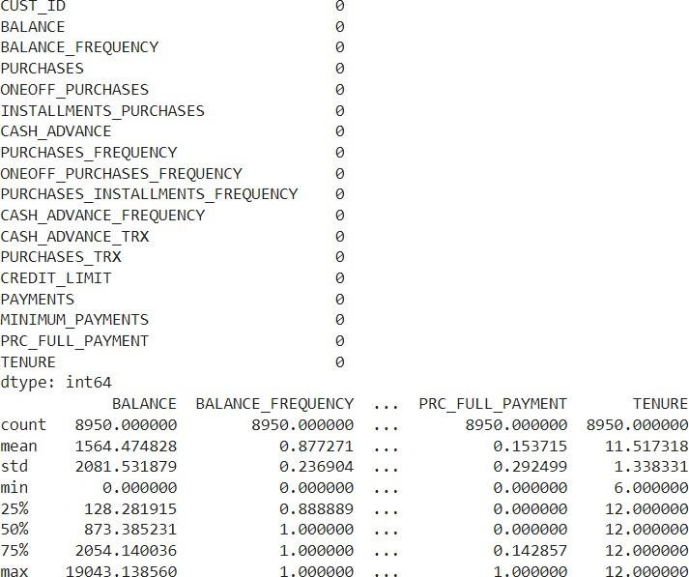

**CODE:**

dataset.drop(['CUST_ID'], axis= 1, inplace = True) #no relevance f or custid

# No Categorical Values found X = dataset.iloc[:,:].values

DEPARTMENT OF COMPUTER APPLICATION

Page | 42

# Using standard scaler

from sklearn.preprocessing import StandardScaler standardscaler= StandardScaler()

X = standardscaler.fit_transform(X) #scaling the values print(X)

# OUTPUT:

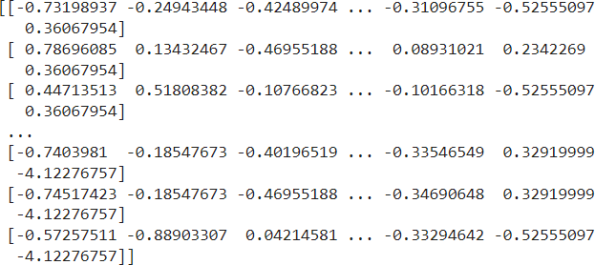

**CODE:**

"""K MEANS CLUSTERING """

#Inertia, or the within-

cluster sum of squares criterion, can be recognized as a measure o f how internally coherent clusters are

from sklearn.cluster import KMeans wss= []

for i in range(1, 11):

kmeans= KMeans(n_clusters = i, init = 'k- means++', random_state = 0)

kmeans.fit(X) wss.ap- pend(kmeans.inertia_)

plt.plot(range(1,11), wss) # selecting 4

DEPARTMENT OF COMPUTER APPLICATION

Page | 43

# OUTPUT:

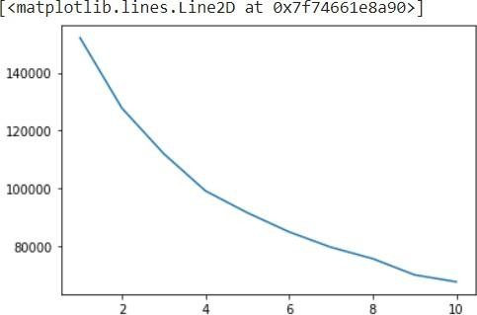

**CODE:**

wss_mean=np.array(wss).mean() print(wss)

print(wss_mean)

print([abs(wss_mean-x) for x in wss]) k=np.argmin([abs(wss_mean-x) for x in wss])+1

# OUTPUT:

[152149.99999999983, 127784.92103208725, 111986.41162208859,

99073.93826774803, 91502.98328256077, 84851.13240432573,

79532.40237691796, 75568.97609993909, 69954.91393943134,

67546.56302862825]

95995.22420537268

[56154.775794627145, 31789.69682671457, 15991.187416715911,

3078.714062375351, 4492.240922811907, 11144.091801046947,

16462.82182845472, 20426.248105433595, 26040.31026594134,

28448.661176744426]

# CODE:

kmeans = KMeans(n_clusters = k, init= 'k- means++', random_state = 0) kmeans.fit(X)

Y_pred_K= kmeans.predict(X) print(Y_pred_K)

#showing the clusters of first 100 persons plt.figure(figsize=(16,4)) plt.plot(range(1,100+1),Y_pred_K[:100],'ro')

# OUTPUT:

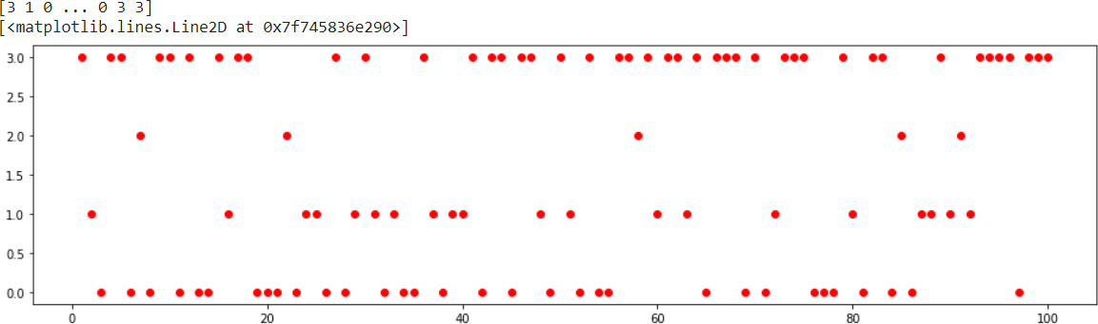

**AIM**

10:Programs on feedforward network to classify any standard dataset available in the public domain.

**Dataset used: HR_comma_sep.csv**

# CODE:

import numpy as np import pandas as pd

# Load data data=pd.read_csv('HR_comma_sep.csv') data.head()

# OUTPUT:

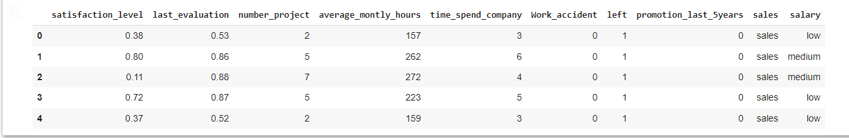

**CODE:**

from sklearn import preprocessing # Creating labelEncoder

le = preprocessing.LabelEncoder()

# Converting string labels into numbers. data['salary']=le.fit_transform(data['salary']) data['sales']=le.fit_transform(data['sales'])

X=data[['satisfaction_level', 'last_evaluation', 'number_project', 'average_montly_hour s', 'time_spend_company', 'Work_accident', 'promotion_last_5years', 'sales', 'salary']]

y=data['left']

# Import train_test_split function

from sklearn.model_selection import train_test_split # Split dataset into training set and test set

X_train, X_test, y_train, y_test = train_test_split(X, y, test_size=0.3, random_state=42

) # 70% training and 30% test

from sklearn.neural_network import MLPClassifier # Create model object

clf = MLPClassifier(hidden_layer_sizes=(6,5), random_state=5,

verbose=False, learning_rate_init=0.01)

# Fit data onto the model clf.fit(X_train,y_train)

# OUTPUT:



**CODE:**

ypred=clf.predict(X_test) # Import accuracy score

from sklearn.metrics import accuracy_score # Calcuate accuracy accuracy_score(y_test,ypred)

# OUTPUT:



**Aim:**

11:Programs on convolutional neural network to classify images from any standard dataset in the public domain.

CODE:

import numpy as np import pandas as pd

# Load data data=pd.read_csv('HR_comma_sep.csv')

data.head()

# Output:

|  |  |  |  |  |  |  |  |  |  |  |
| --- | --- | --- | --- | --- | --- | --- | --- | --- | --- | --- |
|  | **satis- fac- tion_l evel** | **last_e valu- ation** | **num- ber_p**  **ro- ject** | **aver- age_montly**  **_hours** | **time_spen**  **d_com- pany** | **Work**  **_acci- dent** | **le ft** | **promo- tion_last_ 5years** | **sal es** | **sal ar y** |
| **0** | 0.38 | 0.53 | 2 | 157 | 3 | 0 | 1 | 0 | sal es | lo w |
| **1** | 0.80 | 0.86 | 5 | 262 | 6 | 0 | 1 | 0 | sal es | me diu m |
| **2** | 0.11 | 0.88 | 7 | 272 | 4 | 0 | 1 | 0 | sal es | me diu m |
| **3** | 0.72 | 0.87 | 5 | 223 | 5 | 0 | 1 | 0 | sal es | lo w |
| **4** | 0.37 | 0.52 | 2 | 159 | 3 | 0 | 1 | 0 | sal es | lo w |

**CODE:**

from sklearn import preprocessing

# Creating labelEncoder

le = preprocessing.LabelEncoder()

# Converting string labels into numbers. data['salary']=le.fit_transform(data['salary']) data['sales']=le.fit_transform(data['sales'])

X=data[['satisfaction_level', 'last_evaluation', 'number_project', 'average_montly_hours',

'time_spend_company', 'Work_accident', 'promotion_last_5years', 'sales', 'salary']] y=data['left']

# Import train_test_split function

from sklearn.model_selection import train_test_split

# Split dataset into training set and test set

X_train, X_test, y_train, y_test = train_test_split(X, y, test_size=0.3, random_state=42) # 70% training and 30% test

from sklearn.neural_network import MLPClassifier # Create model object

clf = MLPClassifier(hidden_layer_sizes=(6,5), random_state=5,

verbose=False, learning_rate_init=0.01)

# Fit data onto the model clf.fit(X_train,y_train)

ypred=clf.predict(X_test)

# OUTPUT:

MLPClassifier(hidden_layer_sizes=(6, 5), learning_rate_init=0.01, random_state=5)

# CODE:

# Import accuracy score

from sklearn.metrics import accuracy_score # Calcuate accuracy

print ("Accuracy:",accuracy_score(y_test,ypred))

# OUTPUT:

Accuracy: 0.9386666666666666

# CODE:

from sklearn.metrics import classification_report, confusion_matrix print(confusion_matrix(y_test, ypred)) print(classification_report(y_test, ypred))

# OUTPUT:

|  |  |
| --- | --- |
| [[3248 | 180] |
| [ 96 | 976]] |

|  |  |  |  |  |
| --- | --- | --- | --- | --- |
| 0 | precision  0.97 | recall  0.95 | f1-score  0.96 | support  3428 |
| 1 | 0.84 | 0.91 | 0.88 | 1072 |
| accuracy |  |  | 0.94 | 4500 |
| macro avg | 0.91 | 0.93 | 0.92 | 4500 |
| weighted avg | 0.94 | 0.94 | 0.94 | 4500 |

DEPARTMENT OF COMPUTER APPLICATION